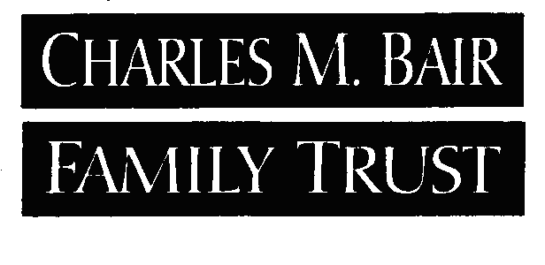

incomplete Application form

Organization name:

Your grant application is being returned for the following reason(s):

Taxpayer ID not included

IRS letter of determination not included

Latest annual information return (Form 990 or 990-EZ) not included

If current information return is on extension – IRS Approved Extension of Time to File Form

Organization did not provide certification as a public charity

Current operating budget or balance sheet not included

Organization’s county not listed on application

Organization not domiciled in Montana (IRS Letter or other documentation indicates organizations main address is not in Montana)

Proposed project/program not explained

Organization is ineligible for application

Application received after deadline (not eligible to resubmit until next
grant round)

Other

Unless specified, you may correct the above listed problem(s) and resubmit your application before the current deadline to have it considered in this grant round. If you choose not to resubmit, please consider reapplying in the next grant round.

Please refer to the enclosed application guidelines for further reference.

